Low Histamine Foods List and Histamine Intolerance

Low Histamine Foods

Beverages:
- Coconut water
- Coffee
- Herbal Teas
- Juice (freshly squeezed from allowed fruit)
- Mineral water/ Water

Dairy: (grass-fed)
- A2 milk (plain)
- Butter
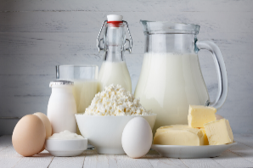
- Cream
- Cream Cheese
- Ghee
- Goat milk
- Ricotta
- Sheep milk

Eggs:
- Pasture Raised Organic eggs

Fats/Oils:
- Avocado
- Butter – Grass fed
- Coconut
- Flax
- Ghee
- Palm
- Sesame
- Sunflower

Fruits:
- Apple
- Blackberry/Blueberry/Raspberry/Cranberry
- Cantaloupe, Honeydew, Watermelon
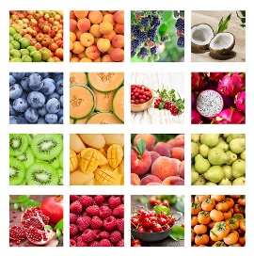
- Cherry
- Grapes
- Kiwi
- Lemon/Lime (1/2 tsp)
- Mango
- Nectarine, Peach
- Pear

Grains/Carbs: Any gluten free:
- Buckwheat
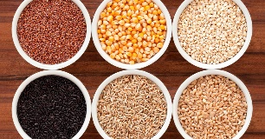
- Corn (if tolerated)
- Crackers (gluten free)
- Oats
- Pasta (gluten free)
- Quinoa
- Rice (Black, Brown, White)
- Tapioca Starch/flour

Legumes:
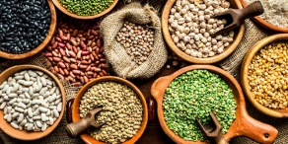
- Beans (dried; Kidney, Black, Navy)
- Garbanzo/Chickpeas
- Lentils

Meats:

(organic, freshly cooked, un-aged, not ground)
- Beef
- Bison
- Chicken
- Lamb
- Pork
- Scallops
- Salmon
- Turkey

Nuts/Seeds:
- Almonds (blanched, skins)
- Chia Seeds
- Flax
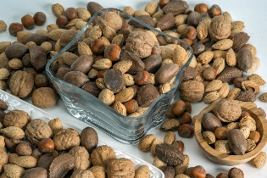
- Hazelnuts
- Macadamias
- Pecan
- Pistachios
- Poppy Seed
- Pumpkin
- Sesame
- Sunflower

Spices/Herbs:
- Basil
- Bay leaves
- Cilantro
- Cumin
- Dill
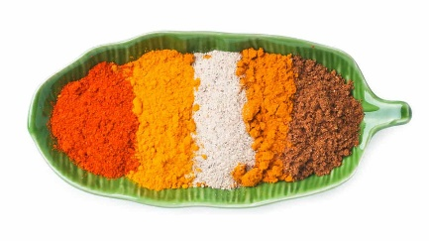
- Fennel
- Garlic
- Ginger
- Mint
- Oregano
- Parsley
- Peppermint
- Rosemary
- Sage
- Salt (unrefined)
- Thyme
- Turmeric

Starches (feed good gut bacteria):
- Almond flour
- Coconut (fresh)
- Flax
- Hi-Maize
- Millet
- Parsnips
- Potatoes
- Rutabagas
- Sweet Potatoes

Sweeteners:

(anything that raises blood sugar increase histamine levels)
- Inulin
- Maple syrup (use sparingly)
- Monk fruit
- Stevia

Vegetables: (fresh/frozen)
- Artichokes
- Arugula
- Asparagus
- Beets
- Bok Choy
- Broccoli/Broccolini
- Brussel Sprouts
- Cabbage
- Carrots
- Cauliflower
- Cucumber
- Daikon radishes
- Kohlrabi
- Leafy Greens
- Lettuce (Butter, Iceberg, Radicchio, Romaine)
- Onions
- Parsley
- Peppers (bell, hot)
- Radishes
- Rhubarb
- Squash (Butternut, Spaghetti, Summer, Winter)
- Sweet Potatoes
- Swiss Chard
- Turnip
- Zucchini
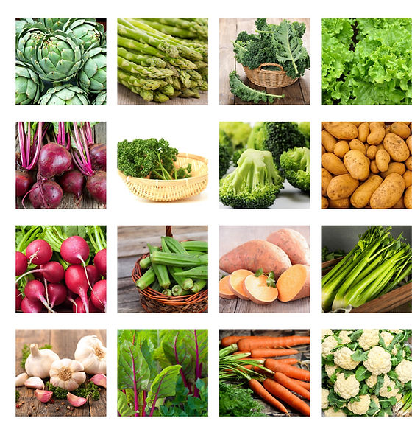

High Histamine Foods

Beverages:
- Beer
- Carbonated drinks
- Cider
- Cocoa
- Drinks w/flavor or spices
- Kombucha
- Tea (all Black, Green, White, Rooibos)
- Wine

Eggs:
- Eggs prepared with restricted ingredients
- Raw egg white (eggnog, hollandaise sauce, mayo)

Fats/Oils:
- Fats/Oils with color and/or preservatives
- Margarine
- Salad dressings w/restricted ingredients

Fruits:
- Avocado
- Banana
- Dates/Dried fruits
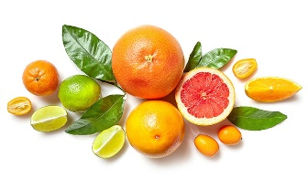
- Grapefruit
- Jams/Jellies/Preservatives
- Orange/Citrus fruits
- Pineapple
- Plums
- Prunes
- Raisins
- Strawberries
- Tomato/Tomato products

Grains/Carbs/Starches:
- Baking mixes
- Bleached flour
- Dessert mixes
- Pasta meals (packaged)
- Pie, Pastry and Fillings (commercial)
- Rice Meals (packaged)

Legumes:
- Beans (canned)
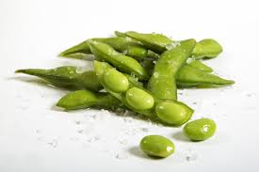
- Lentils (canned)
- Soybeans/Edamame
- Tofu

Meats:
- Beef (99% of all beef is aged)
- Bison
- Cured meats: Bacon, Salami, Pepperoni, Luncheon meats, Hot dogs
- Fish
- Ground Meats
- Shellfish
- Nuts/Seeds:
- Cashews
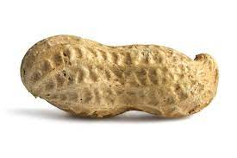
- Coconut (dried)
- Peanuts
- Walnuts

Spices/Herbs:
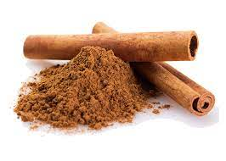
- Allspice
- Cinnamon
- Chili Powder
- Cloves
- Curry Powder
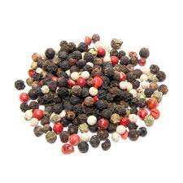
- Cayenne
- MSG
- Mustard
- Nutmeg
- Paprika
- Peppercorns; Black, Green, White

Sweeteners:
- Artificial sweeteners
- Candies
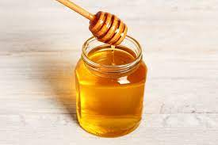
- Corn Syrup
- Flavored syrups
- Honey
- Icing/Frosting
- Molasses
- Sugar

Vegetables: (fresh/frozen)
- Eggplant
- Fermented Foods (Kimchi, Sauerkraut)
- Green beans, String beans
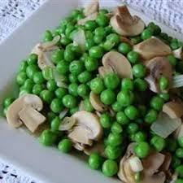
- Mushrooms
- Peas
- Pumpkin

